**BUILD MOBILE APP**

**CONFIGURE THE APPLICATION TO RECEIVE THE DATA FROM**

**CLOUD**

|  |  |
| --- | --- |
| Date | 03 November 2022 |
| Team ID | PNT2022TMID43091 |
| Project Name | Project – IOT Based Real – time River  Water Quality Monitoring and Control System |
| Maximum Marks | 4 Marks |

This is created through the use of gateway nodes to create a **Virtual Data**  **Warehouse.** This Virtual Data Warehouse allows application developers to map access to remote data points.

This software-defined gateway is run adjacent to the application it serves and can be deployed within a cloud environment or in a data center.

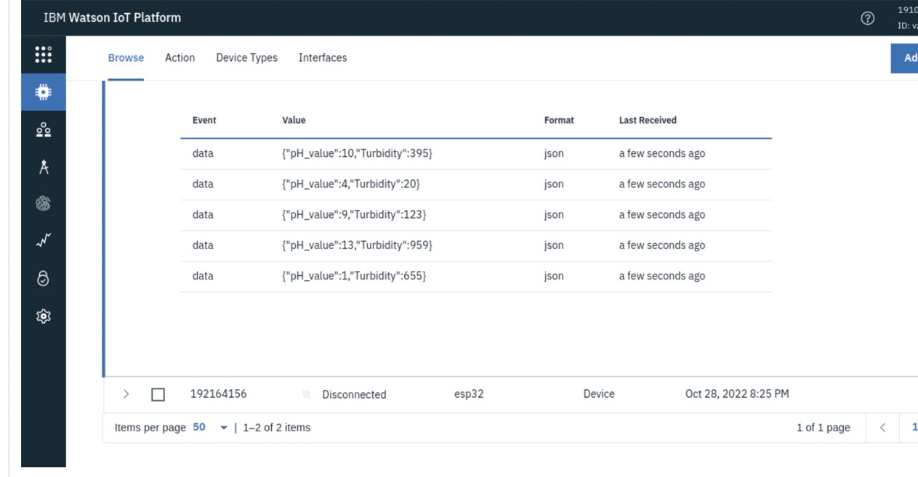

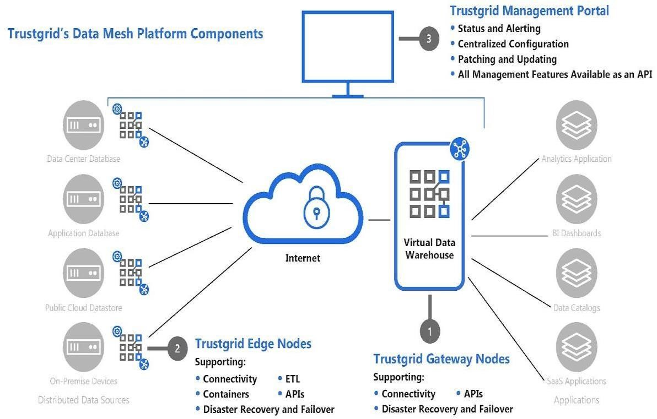

This Virtual Data Warehouse allows for the virtual aggregation of data so that an application (or many applications) can easily consume it. Once a data source is added to the Virtual Data Warehouse an application has secure, real-time, persistent access to that data set.

Hardware device – The hardware device is one of the easiest methods of deployment because Trust grid handles all of the software imaging, logistics and deployment support for the end-user. A hardware appliance is ideal for environments with limited onsite support